9. Now, Create the WordPress Deployment

|  |
| --- |
| $ curl -k https://pastebin.com/raw/E43qyckF > wordpress.yml |

10. Apply the wordpress.yml after replacing <your-name> with your name.

|  |
| --- |
| $ kubectl create -f wordpress.yml -n <your-name> |

11. Check the Pods deployment.

|  |
| --- |
| $ kubectl get po -n <your-name> |

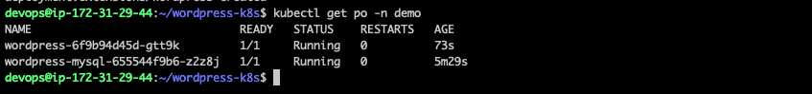

12. Check the Persistent Volume Claims

|  |
| --- |
| $ kubectl get pvc -n <your-name> |

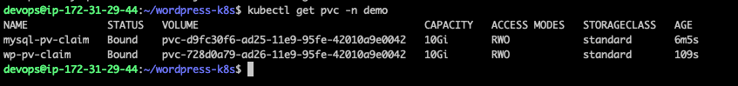

13. Check where the POD is deployed.

|  |
| --- |
| $ kubectl get po -o wide -n <your-name> |



14. Get the Public IP of the NODE where the Pod is deployed.

|  |
| --- |
| $ kubectl get nodes -o wide |

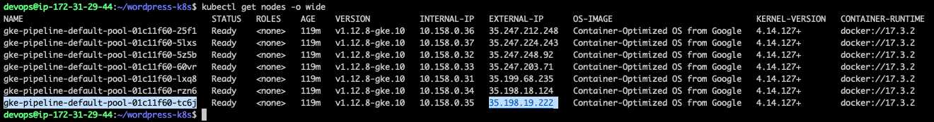

15. Check the NODEPORT on which your wordpress pod is exposed.

|  |
| --- |
| $ kubectl get svc -n <your-name> |

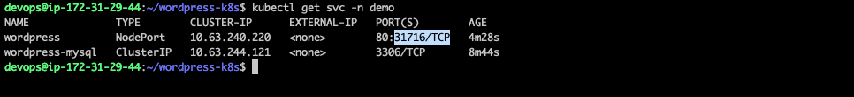

16. Access the wordpress application using the Node Public IP and the NodePort as shown below

